What is Memory?
Computer memory can be defined as a collection of some data represented in the binary format. On the basis of various functions, memory can be classified into various categories. We will discuss each one of them later in detail.
A computer device that is capable to store any information or data temporally or permanently, is called storage device.

How Data is being stored in a computer system?
In order to understand memory management, we have to make everything clear about how data is being stored in a computer system.
Machine understands only binary language that is 0 or 1. Computer converts every data into binary language first and then stores it into the memory.
That means if we have a program line written as int α = 10 then the computer converts it into the binary language and then store it into the memory blocks.
The representation of inti = 10 is shown below.
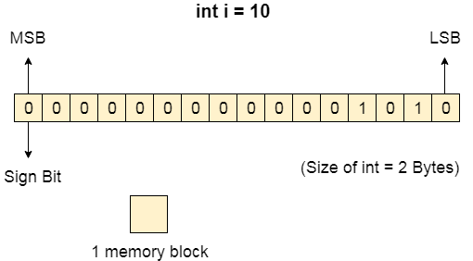
The binary representation of 10 is 1010. Here, we are considering 32 bit system therefore, the size of int is 2 bytes i.e. 16 bit. 1 memory block stores 1 bit. If we are using signed integer then the most significant bit in the memory array is always a signed bit.
Signed bit value 0 represents positive integer while 1 represents negative integer. Here, the range of values that can be stored using the memory array is -32768 to +32767.
well, we can enlarge this range by using unsigned int. in that case, the bit which is now storing the sign will also store the bit value and therefore the range will be 0 to 65,535.

Need for Multi programming
However, The CPU can directly access the main memory, Registers and cache of the system. The program always executes in main memory. The size of main memory affects degree of Multi programming to most of the extant. If the size of the main memory is larger than CPU can load more processes in the main memory at the same time and therefore will increase degree of Multi programming as well as CPU utilization.
- Let's consider,
- Process Size = 4 MB
- Main memory size = 4 MB
- The process can only reside in the main memory at any time.
- If the time for which the process does IO is P,

- Then,

- CPU utilization = (1-P)
- let's say,
- P = 70%
- CPU utilization = 30 %
- Now, increase the memory size, Let's say it is 8 MB.
- Process Size = 4 MB
- Two processes can reside in the main memory at the same time.
- Let's say the time for which, one process does its IO is P,

- Then

- CPU utilization = (1-P^2)
- let's say P = 70 %
- CPU utilization = (1-0.49) =0.51 = 51 %
Therefore, we can state that the CPU utilization will be increased if the memory size gets increased.

Fixed Partitioning
The earliest and one of the simplest technique which can be used to load more than one processes into the main memory is Fixed partitioning or Contiguous memory allocation.
In this technique, the main memory is divided into partitions of equal or different sizes. The operating system always resides in the first partition while the other partitions can be used to store user processes. The memory is assigned to the processes in contiguous way.
In fixed partitioning,
- The partitions cannot overlap.
- A process must be contiguously present in a partition for the execution.
There are various cons of using this technique.
1. Internal Fragmentation
If the size of the process is lesser then the total size of the partition then some size of the partition get wasted and remain unused. This is wastage of the memory and called internal fragmentation.
As shown in the image below, the 4 MB partition is used to load only 3 MB process and the remaining 1 MB got wasted.
2. External Fragmentation
The total unused space of various partitions cannot be used to load the processes even though there is space available but not in the contiguous form.
As shown in the image below, the remaining 1 MB space of each partition cannot be used as a unit to store a 4 MB process. Despite of the fact that the sufficient space is available to load the process, process will not be loaded.
3. Limitation on the size of the process
If the process size is larger than the size of maximum sized partition then that process cannot be loaded into the memory. Therefore, a limitation can be imposed on the process size that is it cannot be larger than the size of the largest partition.
4. Degree of multiprogramming is less
By Degree of multi programming, we simply mean the maximum number of processes that can be loaded into the memory at the same time. In fixed partitioning, the degree of multiprogramming is fixed and very less due to the fact that the size of the partition cannot be varied according to the size of processes.

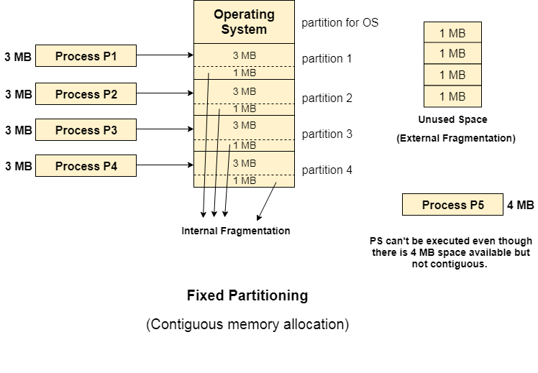
Dynamic Partitioning
Dynamic partitioning tries to overcome the problems caused by fixed partitioning. In this technique, the partition size is not declared initially. It is declared at the time of process loading.
The first partition is reserved for the operating system. The remaining space is divided into parts. The size of each partition will be equal to the size of the process. The partition size varies according to the need of the process so that the internal fragmentation can be avoided.
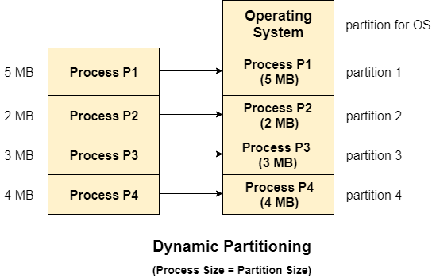

Advantages of Dynamic Partitioning over fixed partitioning

1. No Internal Fragmentation
Given the fact that the partitions in dynamic partitioning are created according to the need of the process, It is clear that there will not be any internal fragmentation because there will not be any unused remaining space in the partition.

2. No Limitation on the size of the process
In Fixed partitioning, the process with the size greater than the size of the largest partition could not be executed due to the lack of sufficient contiguous memory. Here, In Dynamic partitioning, the process size can't be restricted since the partition size is decided according to the process size. lay VideoForward Skip 10s

3. Degree of multiprogramming is dynamic
Due to the absence of internal fragmentation, there will not be any unused space in the partition hence more processes can be loaded in the memory at the same time.

Disadvantages of dynamic partitioning

External Fragmentation
Absence of internal fragmentation doesn't mean that there will not be external fragmentation.
Let's consider three processes P1 (1 MB) and P2 (3 MB) and P3 (1 MB) are being loaded in the respective partitions of the main memory.
After some time P1 and P3 got completed and their assigned space is freed. Now there are two unused partitions (1 MB and 1 MB) available in the main memory but they cannot be used to load a 2 MB process in the memory since they are not contiguously located.
The rule says that the process must be contiguously present in the main memory to get executed. We need to change this rule to avoid external fragmentation.
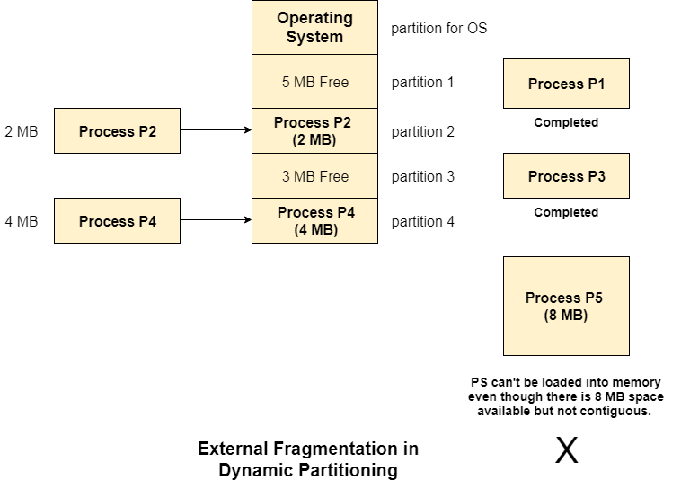

Complex Memory Allocation
In Fixed partitioning, the list of partitions is made once and will never change but in dynamic partitioning, the allocation and deallocation is very complex since the partition size will be varied every time when it is assigned to a new process. OS has to keep track of all the partitions.
Due to the fact that the allocation and deallocation are done very frequently in dynamic memory allocation and the partition size will be changed at each time, it is going to be very difficult for OS to manage everything.

Compaction
We got to know that the dynamic partitioning suffers from external fragmentation. However, this can cause some serious problems.
To avoid compaction, we need to change the rule which says that the process can't be stored in the different places in the memory.
We can also use compaction to minimize the probability of external fragmentation. In compaction, all the free partitions are made contiguous and all the loaded partitions are brought together.
By applying this technique, we can store the bigger processes in the memory. The free partitions are merged which can now be allocated according to the needs of new processes. This technique is also called defragmentation.
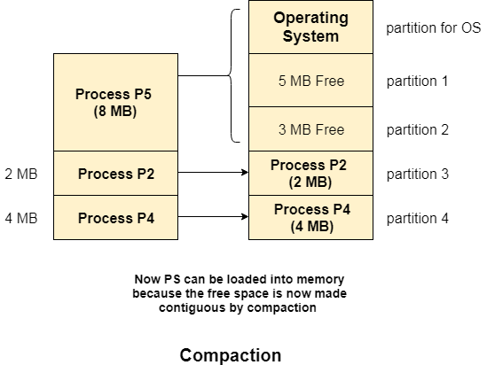
As shown in the image above, the process P5, which could not be loaded into the memory due to the lack of contiguous space, can be loaded now in the memory since the free partitions are made contiguous.

Problem with Compaction
The efficiency of the system is decreased in the case of compaction due to the fact that all the free spaces will be transferred from several places to a single place.
Huge amount of time is invested for this procedure and the CPU will remain idle for all this time. Despite of the fact that the compaction avoids external fragmentation, it makes system inefficient.
Let us consider that OS needs 6 NS to copy 1 byte from one place to another.
- 1 B transfer needs 6 NS
- 256 MB transfer needs 256 X 2^20 X 6 X 10 ^ -9 secs
hence, it is proved to some extent that the larger size memory transfer needs some huge amount of time that is in seconds.

Bit Map for Dynamic Partitioning
The Main concern for dynamic partitioning is keeping track of all the free and allocated partitions. However, the Operating system uses following data structures for this task.
- Bit Map
- Linked List
Bit Map is the least famous data structure to store the details. In this scheme, the main memory is divided into the collection of allocation units. One or more allocation units may be allocated to a process according to the need of that process. However, the size of the allocation unit is fixed that is defined by the Operating System and never changed. Although the partition size may vary but the allocation size is fixed.
The main task of the operating system is to keep track of whether the partition is free or filled. For this purpose, the operating system also manages another data structure that is called bitmap.
The process or the hole in Allocation units is represented by a flag bit of bitmap. In the image shown below, a flag bit is defined for every bit of allocation units. However, it is not the general case, it depends on the OS that, for how many bits of the allocation units, it wants to store the flag bit.
The flag bit is set to 1 if there is a contiguously present process at the adjacent bit in allocation unit otherwise it is set to 0.
A string of 0s in the bitmap shows that there is a hole in the relative Allocation unit while the string of 1s represents the process in the relative allocation unit.
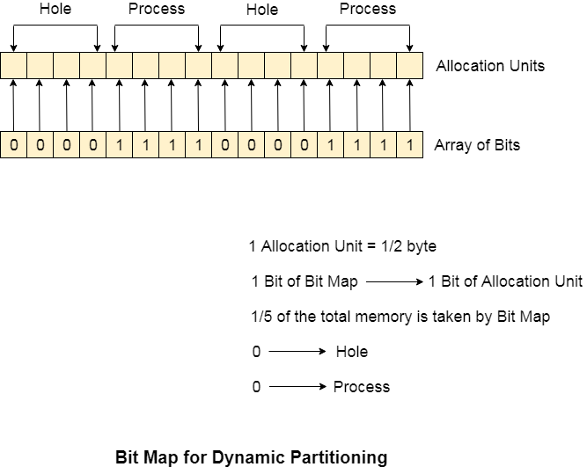

Disadvantages of using Bitmap
1. The OS has to assign some memory for bitmap as well since it stores the details about allocation units. That much amount of memory cannot be used to load any process therefore that decreases the degree of multiprogramming as well as throughput.
In the above image,
The allocation unit is of 4 bits that is 0.5 bits. Here, 1 bit of the bitmap is representing 1 bit of allocation unit.
- Size of 1 allocation unit = 4 bits
- Size of bitmap = 1/(4+1) = 1/5 of total main memory.
Therefore, in this bitmap configuration, 1/5 of total main memory is wasted.
2. To identify any hole in the memory, the OS need to search the string of 0s in the bitmap. This searching takes a huge amount of time which makes the system inefficient to some extent

Partitioning Algorithms
There are various algorithms which are implemented by the Operating System in order to find out the holes in the linked list and allocate them to the processes.
The explanation about each of the algorithm is given below.
1. First Fit Algorithm
First Fit algorithm scans the linked list and whenever it finds the first big enough hole to store a process, it stops scanning and load the process into that hole. This procedure produces two partitions. Out of them, one partition will be a hole while the other partition will store the process.
PlayNext
Unmute
Current TimeÂ 0:03
/
DurationÂ 18:10
Loaded: 3.67%
Â
Fullscreen
First Fit algorithm maintains the linked list according to the increasing order of starting index. This is the simplest to implement among all the algorithms and produces bigger holes as compare to the other algorithms.
2. Next Fit Algorithm
Next Fit algorithm is similar to First Fit algorithm except the fact that, Next fit scans the linked list from the node where it previously allocated a hole.
Next fit doesn't scan the whole list, it starts scanning the list from the next node. The idea behind the next fit is the fact that the list has been scanned once therefore the probability of finding the hole is larger in the remaining part of the list.
Experiments over the algorithm have shown that the next fit is not better then the first fit. So it is not being used these days in most of the cases.
3. Best Fit Algorithm
The Best Fit algorithm tries to find out the smallest hole possible in the list that can accommodate the size requirement of the process.
Using Best Fit has some disadvantages.
- 1. It is slower because it scans the entire list every time and tries to find out the smallest hole which can satisfy the requirement the process.
- Due to the fact that the difference between the whole size and the process size is very small, the holes produced will be as small as it cannot be used to load any process and therefore it remains useless.
Despite of the fact that the name of the algorithm is best fit, It is not the best algorithm among all.

4. Worst Fit Algorithm
The worst fit algorithm scans the entire list every time and tries to find out the biggest hole in the list which can fulfill the requirement of the process.
Despite of the fact that this algorithm produces the larger holes to load the other processes, this is not the better approach due to the fact that it is slower because it searches the entire list every time again and again.
5. Quick Fit Algorithm
The quick fit algorithm suggestsmaintaining the different lists of frequently used sizes. Although, it is not practically suggestible because the procedure takes so much time to create the different lists and then expending the holes to load a process.
The first fit algorithm is the best algorithm among all because
- It takes lesser time compare to the other algorithms.
- It produces bigger holes that can be used to load other processes later on.
- It is easiest to implement.

GATE question on best fit and first fit
From the GATE point of view, Numerical on best fit and first fit are being asked frequently in 1 mark. Let's have a look on the one given as below.

Q. Process requests are given as;
25 K , 50 K , 100 K , 75 K
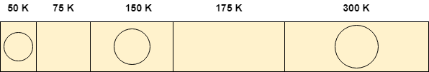
Determine the algorithm which can optimally satisfy this requirement.
- First Fit algorithm
- Best Fit Algorithm
- Neither of the two
- Both of them
In the question, there are five partitions in the memory. 3 partitions are having processes inside them and two partitions are holes.
Our task is to check the algorithm which can satisfy the request optimally.

Using First Fit algorithm
Let's see, how first fit algorithm works on this problem.

1. 25 K requirement
The algorithm scans the list until it gets first hole which should be big enough to satisfy the request of 25 K. it gets the space in the second partition which is free hence it allocates 25 K out of 75 K to the process and the remaining 50 K is produced as hole.
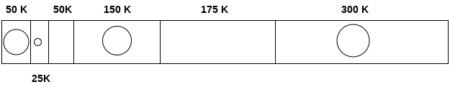

2. 50 K requirement
The 50 K requirement can be fulfilled by allocating the third partition which is 50 K in size to the process. No free space is produced as free space.
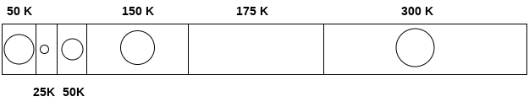

3. 100 K requirement
100 K requirement can be fulfilled by using the fifth partition of 175 K size. Out of 175 K, 100 K will be allocated and remaining 75 K will be there as a hole.
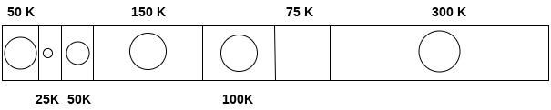

4. 75 K requirement
Since we are having a 75 K free partition hence we can allocate that much space to the process which is demanding just 75 K space.
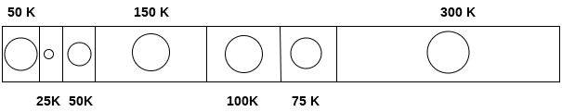

Using first fit algorithm, we have fulfilled the entire request optimally and no useless space is remaining.
Let's see, How Best Fit algorithm performs for the problem.

Using Best Fit Algorithm

1. 25 K requirement
To allocate 25 K space using best fit approach, need to scan the whole list and then we find that a 75 K partition is free and the smallest among all, which can accommodate the need of the process.
Therefore 25 K out of those 75 K free partition is allocated to the process and the remaining 5o K is produced as a hole.
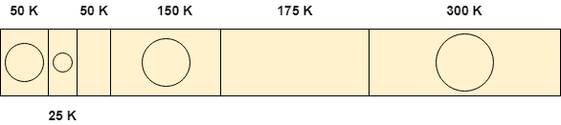

2. 50 K requirement
To satisfy this need, we will again scan the whole list and then find the 50 K space is free which the exact match of the need is. Therefore, it will be allocated for the process.
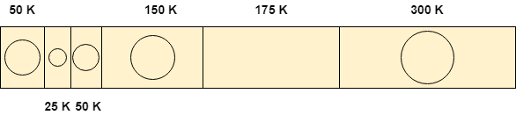

3. 100 K requirement
100 K need is close enough to the 175 K space. The algorithm scans the whole list and then allocates 100 K out of 175 K from the 5th free partition.
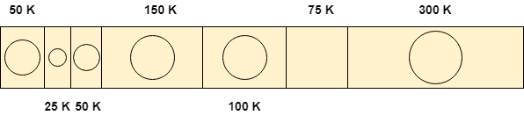

4. 75 K requirement
75 K requirement will get the space of 75 K from the 6th free partition but the algorithm will scan the whole list in the process of taking this decision.
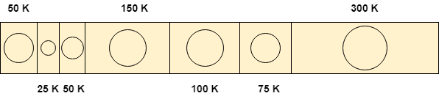
By following both of the algorithms, we have noticed that both the algorithms perform similar to most of the extant in this case.
Both can satisfy the need of the processes but however, the best fit algorithm scans the list again and again which takes lot of time.
Therefore, if you ask me that which algorithm performs in more optimal way then it will be First Fit algorithm for sure.
Therefore, the answer in this case is A.

Paging in OS (Operating System)
In Operating Systems, Paging is a storage mechanism used to retrieve processes from the secondary storage into the main memory in the form of pages.
The main idea behind the paging is to divide each process in the form of pages. The main memory will also be divided in the form of frames.
One page of the process is to be stored in one of the frames of the memory. The pages can be stored at the different locations of the memory but the priority is always to find the contiguous frames or holes.
Pages of the process are brought into the main memory only when they are required otherwise they reside in the secondary storage.
Different operating system defines different frame sizes. The sizes of each frame must be equal. Considering the fact that the pages are mapped to the frames in Paging, page size needs to be as same as frame size.
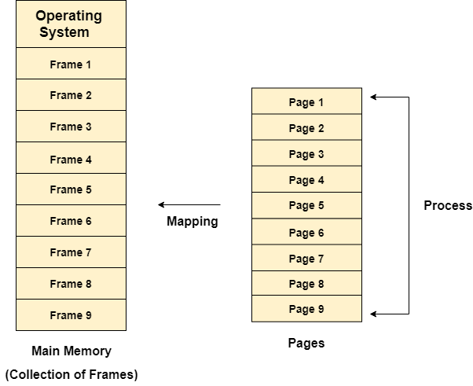

Example
Let us consider the main memory size 16 Kb and Frame size is 1 KB therefore the main memory will be divided into the collection of 16 frames of 1 KB each.
There are 4 processes in the system that is P1, P2, P3 and P4 of 4 KB each. Each process is divided into pages of 1 KB each so that one page can be stored in one frame.
Initially, all the frames are empty therefore pages of the processes will get stored in the contiguous way.
Frames, pages and the mapping between the two is shown in the image below.
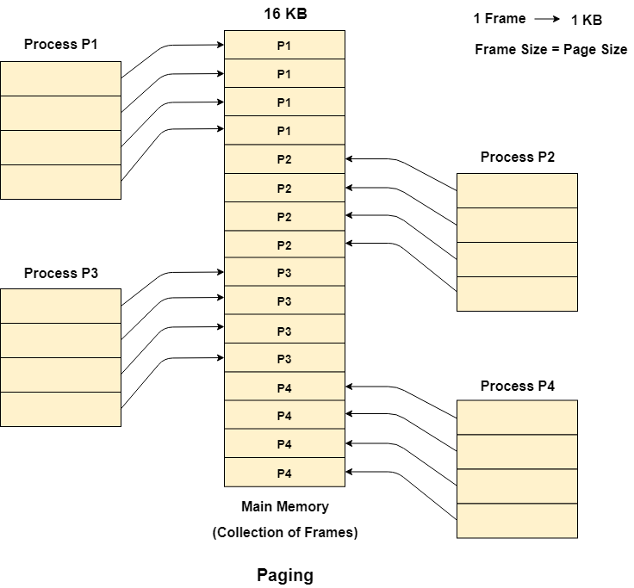
Let us consider that, P2 and P4 are moved to waiting state after some time. Now, 8 frames become empty and therefore other pages can be loaded in that empty place. The process P5 of size 8 KB (8 pages) is waiting inside the ready queue.
Given the fact that, we have 8 non contiguous frames available in the memory and paging provides the flexibility of storing the process at the different places. Therefore, we can load the pages of process P5 in the place of P2 and P4.
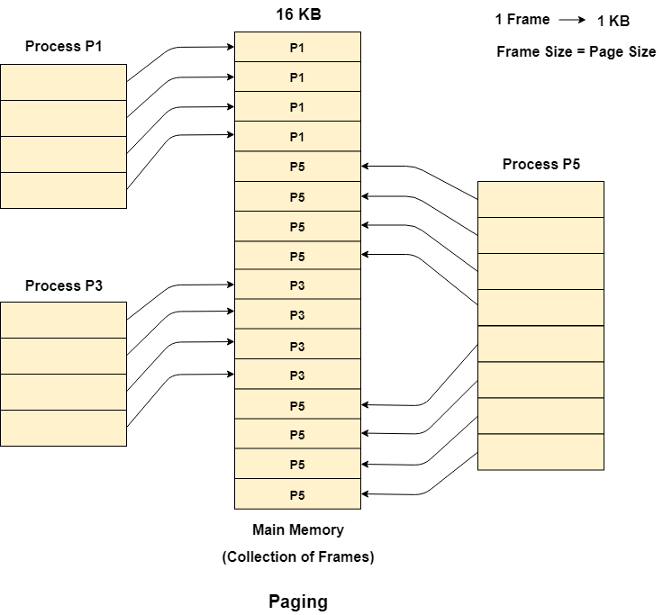

Memory Management Unit
The purpose of Memory Management Unit (MMU) is to convert the logical address into the physical address. The logical address is the address generated by the CPU for every page while the physical address is the actual address of the frame where each page will be stored.
When a page is to be accessed by the CPU by using the logical address, the operating system needs to obtain the physical address to access that page physically.
The logical address has two parts.
- Page Number
- Offset
Memory management unit of OS needs to convert the page number to the frame number.
Example
Considering the above image, let's say that the CPU demands 10th word of 4th page of process P3. Since the page number 4 of process P1 gets stored at frame number 9 therefore the 10th word of 9th frame will be returned as the physical address.

Basics of Binary Addresses
Computer system assigns the binary addresses to the memory locations. However, The system uses amount of bits to address a memory location.
Using 1 bit, we can address two memory locations. Using 2 bits we can address 4 and using 3 bits we can address 8 memory locations.
A pattern can be identified in the mapping between the number of bits in the address and the range of the memory locations.
We know,
PlayNext
Unmute
Current TimeÂ 0:03
/
DurationÂ 18:10
Loaded: 3.67%
Â
Fullscreen
- Using 1 Bit we can represent 2^1 i.e 2 memory locations.
- Using 2 bits, we can represent 2^2 i.e. 4 memory locations.
- Using 3 bits, we can represent 2^3 i.e. 8 memory locations.
- Therefore, if we generalize this,
- Using n bits, we can assign 2^n memory locations.

- n bits of address → 2 ^ n memory locations
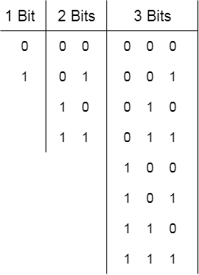
these n bits can be divided into two parts, that are, K bits and (n-k) bits.
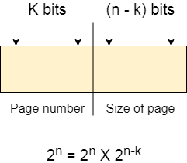

Physical and Logical Address Space

Physical Address Space
Physical address space in a system can be defined as the size of the main memory. It is really important to compare the process size with the physical address space. The process size must be less than the physical address space.

Physical Address Space = Size of the Main Memory
If, physical address space = 64 KB = 2 ^ 6 KB = 2 ^ 6 X 2 ^ 10 Bytes = 2 ^ 16 bytes
Let us consider,
word size = 8 Bytes = 2 ^ 3 Bytes
Hence,
Physical address space (in words) = (2 ^ 16) / (2 ^ 3) = 2 ^ 13 Words
Therefore,
Physical Address = 13 bits
In General,
If, Physical Address Space = N Words
then, Physical Address = log₂ N

Logical Address Space
Logical address space can be defined as the size of the process. The size of the process should be less enough so that it can reside in the main memory.
Let's say,
Logical Address Space = 128 MB = (2 ^ 7 X 2 ^ 20) Bytes = 2 ^ 27 Bytes
Word size = 4 Bytes = 2 ^ 2 Bytes
Logical Address Space (in words) = (2 ^ 27) / (2 ^ 2) = 2 ^ 25 Words
Logical Address = 25 Bits
In general,
If, logical address space = L words
Then, Logical Address = Log₂L bits

What is a Word?
The Word is the smallest unit of the memory. It is the collection of bytes. Every operating system defines different word sizes after analyzing the n-bit address that is inputted to the decoder and the 2 ^ n memory locations that are produced from the decoder.

Page Table in OS
Page Table is a data structure used by the virtual memory system to store the mapping between logical addresses and physical addresses.
Logical addresses are generated by the CPU for the pages of the processes therefore they are generally used by the processes.
Physical addresses are the actual frame address of the memory. They are generally used by the hardware or more specifically by RAM subsystems.
The image given below considers,
Physical Address Space = M words
Logical Address Space = L words
Page Size = P words
Physical Address = log ₂ M = m bits
Logical Address = log ₂ L = l bits
page offset = log ₂ P = p bits
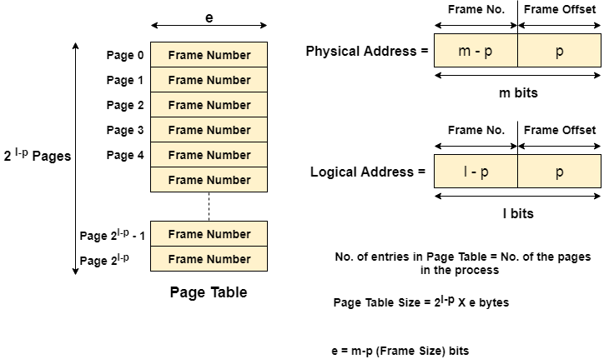
The CPU always accesses the processes through their logical addresses. However, the main memory recognizes physical address only.
In this situation, a unit named as Memory Management Unit comes into the picture. It converts the page number of the logical address to the frame number of the physical address. The offset remains same in both the addresses.
To perform this task, Memory Management unit needs a special kind of mapping which is done by page table. The page table stores all the Frame numbers corresponding to the page numbers of the page table.
In other words, the page table maps the page number to its actual location (frame number) in the memory.
In the image given below shows, how the required word of the frame is accessed with the help of offset.
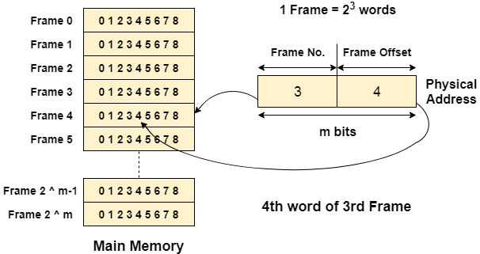

Mapping from page table to main memory
In operating systems, there is always a requirement of mapping from logical address to the physical address. However, this process involves various steps which are defined as follows.

1. Generation of logical address
CPU generates logical address for each page of the process. This contains two parts: page number and offset.

2. Scaling
To determine the actual page number of the process, CPU stores the page table base in a special register. Each time the address is generated, the value of the page table base is added to the page number to get the actual location of the page entry in the table. This process is called scaling.

3. Generation of physical Address
The frame number of the desired page is determined by its entry in the page table. A physical address is generated which also contains two parts : frame number and offset. The Offset will be similar to the offset of the logical address therefore it will be copied from the logical address.

4. Getting Actual Frame Number
The frame number and the offset from the physical address is mapped to the main memory in order to get the actual word address.

Page Table Entry
Along with page frame number, the page table also contains some of the bits representing the extra information regarding the page.
Let's see what the each bit represents about the page.

1. Caching Disabled
Sometimes, there are differences between the information closest to the CPU and the information closest to the user. Operating system always wants CPU to access user's data as soon as possible. CPU accesses cache which can be inaccurate in some of the cases, therefore, OS can disable the cache for the required pages. This bit is set to 1 if the cache is disabled.

2. Referenced
There are variouspage replacement algorithms which will be covered later in this tutorial. This bit is set to 1 if the page is referred in the last clock cycle otherwise it remains 0.

3. Modified
This bit will be set if the page has been modified otherwise it remains 0.

4. Protection
The protection field represents the protection level which is applied on the page. It can be read only or read & write or execute. We need to remember that it is not a bit rather it is a field which contains many bits.

5. Present/Absent
In the concept of demand paging, all the pages doesn't need to be present in the main memory Therefore, for all the pages that are present in the main memory, this bit will be set to 1 and the bit will be 0 for all the pages which are absent.
If some page is not present in the main memory then it is called page fault.

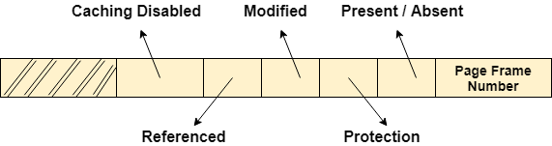Size of the page table
However, the part of the process which is being executed by the CPU must be present in the main memory during that time period. The page table must also be present in the main memory all the time because it has the entry for all the pages.
The size of the page table depends upon the number of entries in the table and the bytes stored in one entry.
Let's consider,
- Logical Address = 24 bits
- Logical Address space = 2 ^ 24 bytes
- Let's say, Page size = 4 KB = 2 ^ 12 Bytes
- Page offset = 12
- Number of bits in a page = Logical Address - Page Offset = 24 - 12 = 12 bits
- Number of pages = 2 ^ 12 = 2 X 2 X 10 ^ 10 = 4 KB
- Let's say, Page table entry = 1 Byte
- Therefore, the size of the page table = 4 KB X 1 Byte = 4 KB
Here we are lucky enough to get the page table size equal to the frame size. Now, the page table will be simply stored in one of the frames of the main memory. The CPU maintains a register which contains the base address of that frame, every page number from the logical address will first be added to that base address so that we can access the actual location of the word being asked.
However, in some cases, the page table size and the frame size might not be same. In those cases, the page table is considered as the collection of frames and will be stored in the different frames.
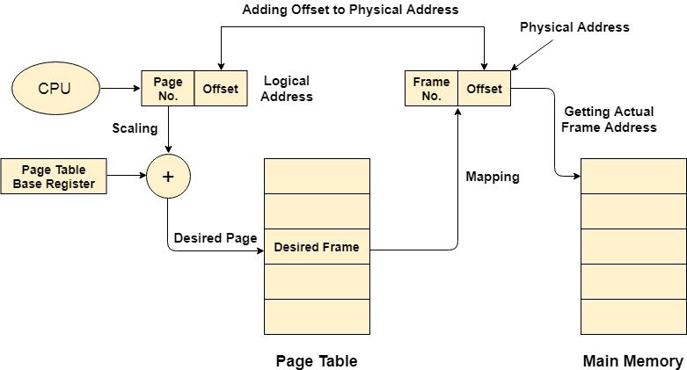

Finding Optimal Page Size
We have seen that the bigger page table size cause an extra overhead because we have to divide that table into the pages and then store that into the main memory.
Our concern must be about executing processes not on the execution of page table. Page table provides a support for the execution of the process. The larger the page Table, the higher the overhead.
We know that,
- Page Table Size = number of page entries in page table X size of one page entry
- Let's consider an example,
- Virtual Address Space = 2 GB = 2 X 2 ^ 30 Bytes
- Page Size = 2 KB = 2 X 2 ^ 10 Bytes
- Number of Pages in Page Table = (2 X 2 ^ 30)/(2 X 2 ^ 10) = 1 M pages
There will be 1 million pages which is quite big number. However, try to make page size larger, say 2 MB.
Then, Number of pages in page table = (2 X 2 ^ 30)/(2 X 2 ^ 20) = 1 K pages.
If we compare the two scenarios, we can find out that the page table size is anti proportional to Page Size.
In Paging, there is always wastage on the last page. If the virtual address space is not a multiple of page size, then there will be some bytes remaining and we have to assign a full page to those many bytes. This is simply a overhead.
Let's consider,
- Page Size = 2 KB
- Virtual Address Space = 17 KB
- Then number of pages = 17 KB / 2 KB
The number of pages will be 9 although the 9th page will only contain 1 byte and the remaining page will be wasted.
In general,
- If page size = p bytes
- Entry size = e bytes
- Virtual Address Space = S bytes
- Then, overhead O = (S/p) X e + (p/2)
On an average, the wasted number of pages in a virtual space is p/2(the half of total number of pages).
For, the minimal overhead,
- ∂O/∂p = 0
- -S/(p^2) + ½ = 0
- p = √ (2.S.e) bytes
Hence, if the page size √(2.S.e) bytes then the overhead will be minimal.

What is Virtual Memory in OS (Operating System)?
Virtual Memory is a storage scheme that provides user an illusion of having a very big main memory. This is done by treating a part of secondary memory as the main memory.
In this scheme, User can load the bigger size processes than the available main memory by having the illusion that the memory is available to load the process.
Instead of loading one big process in the main memory, the Operating System loads the different parts of more than one process in the main memory.
By doing this, the degree of multiprogramming will be increased and therefore, the CPU utilization will also be increased.

How Virtual Memory Works?
In modern word, virtual memory has become quite common these days. In this scheme, whenever some pages needs to be loaded in the main memory for the execution and the memory is not available for those many pages, then in that case, instead of stopping the pages from entering in the main memory, the OS search for the RAM area that are least used in the recent times or that are not referenced and copy that into the secondary memory to make the space for the new pages in the main memory.
Since all this procedure happens automatically, therefore it makes the computer feel like it is having the unlimited RAM.

Demand Paging
Demand Paging is a popular method of virtual memory management. In demand paging, the pages of a process which are least used, get stored in the secondary memory.
A page is copied to the main memory when its demand is made or page fault occurs. There are various page replacement algorithms which are used to determine the pages which will be replaced. We will discuss each one of them later in detail.

Snapshot of a virtual memory management system
Let us assume 2 processes, P1 and P2, contains 4 pages each. Each page size is 1 KB. The main memory contains 8 frame of 1 KB each. The OS resides in the first two partitions. In the third partition, 1st page of P1 is stored and the other frames are also shown as filled with the different pages of processes in the main memory.
The page tables of both the pages are 1 KB size each and therefore they can be fit in one frame each. The page tables of both the processes contain various information that is also shown in the image.
The CPU contains a register which contains the base address of page table that is 5 in the case of P1 and 7 in the case of P2. This page table base address will be added to the page number of the Logical address when it comes to accessing the actual corresponding entry.
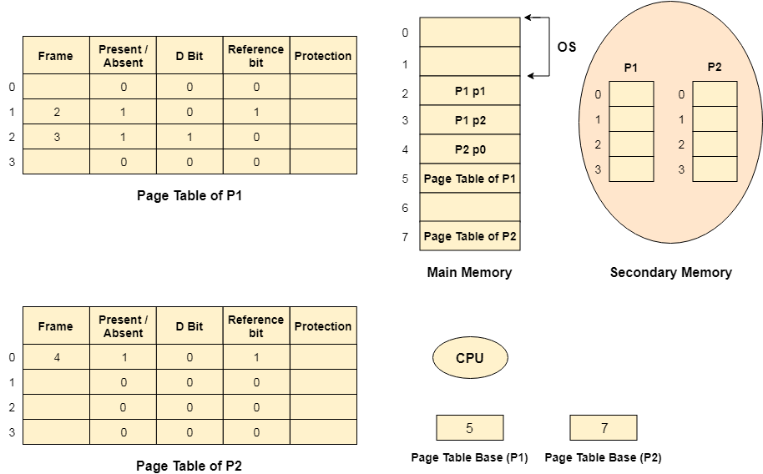

Advantages of Virtual Memory
- The degree of Multiprogramming will be increased.
- User can run large application with less real RAM.
- There is no need to buy more memory RAMs.

Disadvantages of Virtual Memory
- The system becomes slower since swapping takes time.
- It takes more time in switching between applications.
- The user will have the lesser hard disk space for its use.

Translation Look aside buffer

Drawbacks of Paging
- Size of Page table can be very big and therefore it wastes main memory.
- CPU will take more time to read a single word from the main memory.

How to decrease the page table size
- The page table size can be decreased by increasing the page size but it will cause internal fragmentation and there will also be page wastage.
- Other way is to use multilevel paging but that increases the effective access time therefore this is not a practical approach.

How to decrease the effective access time
- CPU can use a register having the page table stored inside it so that the access time to access page table can become quite less but the register are not cheaper and they are very small in compare to the page table size therefore, this is also not a practical approach.
- To overcome these many drawbacks in paging, we have to look for a memory that is cheaper than the register and faster than the main memory so that the time taken by the CPU to access page table again and again can be reduced and it can only focus to access the actual word.

Locality of reference
In operating systems, the concept of locality of reference states that, instead of loading the entire process in the main memory, OS can load only those number of pages in the main memory that are frequently accessed by the CPU and along with that, the OS can also load only those page table entries which are corresponding to those many pages.

Translation look aside buffer (TLB)
A Translation look aside buffer can be defined as a memory cache which can be used to reduce the time taken to access the page table again and again.
It is a memory cache which is closer to the CPU and the time taken by CPU to access TLB is lesser then that taken to access main memory.
In other words, we can say that TLB is faster and smaller than the main memory but cheaper and bigger than the register.
TLB follows the concept of locality of reference which means that it contains only the entries of those many pages that are frequently accessed by the CPU.
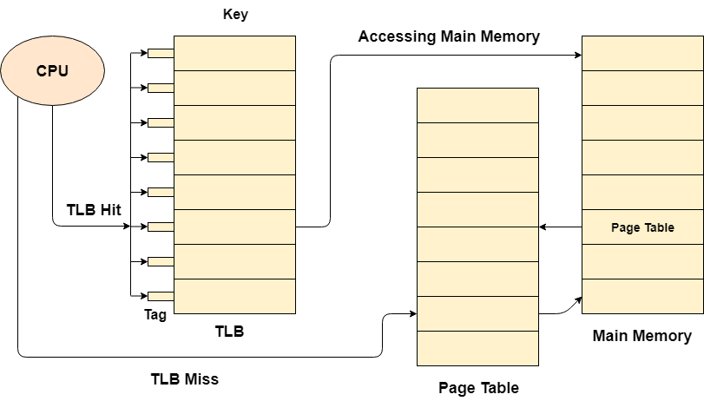
In translation look aside buffers, there are tags and keys with the help of which, the mapping is done.
TLB hit is a condition where the desired entry is found in translation look aside buffer. If this happens then the CPU simply access the actual location in the main memory.
However, if the entry is not found in TLB (TLB miss) then CPU has to access page table in the main memory and then access the actual frame in the main memory.
Therefore, in the case of TLB hit, the effective access time will be lesser as compare to the case of TLB miss.
If the probability of TLB hit is P% (TLB hit rate) then the probability of TLB miss (TLB miss rate) will be (1-P) %.
Therefore, the effective access time can be defined as;
- EAT = P (t + m) + (1 - p) (t + k.m + m)
Where, p → TLB hit rate, t → time taken to access TLB, m → time taken to access main memory k = 1, if the single level paging has been implemented.
By the formula, we come to know that
- Effective access time will be decreased if the TLB hit rate is increased.
- Effective access time will be increased in the case of multilevel paging.

What is Demand Paging in OS (Operating System)?
According to the concept of Virtual Memory, in order to execute some process, only a part of the process needs to be present in the main memory which means that only a few pages will only be present in the main memory at any time.
However, deciding, which pages need to be kept in the main memory and which need to be kept in the secondary memory, is going to be difficult because we cannot say in advance that a process will require a particular page at particular time.
Therefore, to overcome this problem, there is a concept called Demand Paging is introduced. It suggests keeping all pages of the frames in the secondary memory until they are required. In other words, it says that do not load any page in the main memory until it is required.
Whenever any page is referred for the first time in the main memory, then that page will be found in the secondary memory.
After that, it may or may not be present in the main memory depending upon the page replacement algorithm which will be covered later in this tutorial.

What is a Page Fault?
If the referred page is not present in the main memory then there will be a miss and the concept is called Page miss or page fault.
The CPU has to access the missed page from the secondary memory. If the number of page fault is very high then the effective access time of the system will become very high.

What is Thrashing?
If the number of page faults is equal to the number of referred pages or the number of page faults are so high so that the CPU remains busy in just reading the pages from the secondary memory then the effective access time will be the time taken by the CPU to read one word from the secondary memory and it will be so high. The concept is called thrashing.
If the page fault rate is PF %, the time taken in getting a page from the secondary memory and again restarting is S (service time) and the memory access time is ma then the effective access time can be given as;
- EAT = PF X S + (1 - PF) X (ma)

Inverted Page Table
Inverted Page Table is the global page table which is maintained by the Operating System for all the processes. In inverted page table, the number of entries is equal to the number of frames in the main memory. It can be used to overcome the drawbacks of page table.
There is always a space reserved for the page regardless of the fact that whether it is present in the main memory or not. However, this is simply the wastage of the memory if the page is not present.
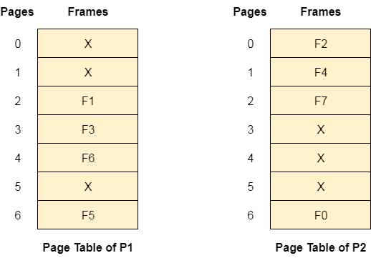
We can save this wastage by just inverting the page table. We can save the details only for the pages which are present in the main memory. Frames are the indices and the information saved inside the block will be Process ID and page number.
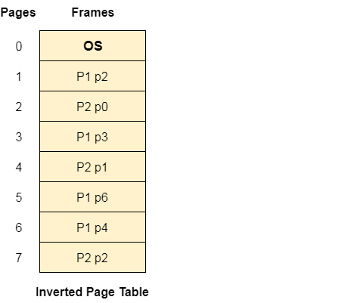

Page Replacement Algorithms in Operating Systems (OS)
Today we are going to learn about Page Replacement Algorithms in Operating Systems (OS). Before knowing about Page Replacement Algorithms in Operating Systems let us learn about Paging in Operating Systems and also a little about Virtual Memory.
Only after understanding the concept of Paging we will understand about Page Replacement Algorithms.

Paging in Operating Systems (OS)
Paging is a storage mechanism. Paging is used to retrieve processes from secondary memory to primary memory.
The main memory is divided into small blocks called pages. Now, each of the pages contains the process which is retrieved into main memory and it is stored in one frame of memory.
It is very important to have pages and frames which are of equal sizes which are very useful for mapping and complete utilization of memory.

Virtual Memory in Operating Systems (OS)
A storage method known as virtual memory gives the user the impression that their main memory is quite large. By considering a portion of secondary memory as the main memory, this is accomplished.
By giving the user the impression that there is memory available to load the process, this approach allows them to load larger size programs than the primary memory that is accessible.
The Operating System loads the many components of several processes in the main memory as opposed to loading a single large process there.
By doing this, the level of multiprogramming will be enhanced, which will increase CPU consumption.

Demand Paging
The Demand Paging is a condition which is occurred in the Virtual Memory. We know that the pages of the process are stored in secondary memory. The page is brought to the main memory when required. We do not know when this requirement is going to occur. So, the pages are brought to the main memory when required by the Page Replacement Algorithms.
So, the process of calling the pages to main memory to secondary memory upon demand is known as Demand Paging.
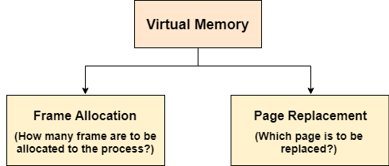
The important jobs of virtual memory in Operating Systems are two. They are:
- Frame Allocation
- Page Replacement.

Frame Allocation in Virtual Memory
Demand paging is used to implement virtual memory, an essential component of operating systems. A page-replacement mechanism and a frame allocation algorithm must be created for demand paging. If you have numerous processes, frame allocation techniques are utilized to determine how many frames to provide to each process.
A Physical Address is required by the Central Processing Unit (CPU) for the frame creation and the physical Addressing provides the actual address to the frame created. For each page a frame must be created.

Frame Allocation Constraints
- The Frames that can be allocated cannot be greater than total number of frames.
- Each process should be given a set minimum amount of frames.
- When fewer frames are allocated then the page fault ration increases and the process execution becomes less efficient
- There ought to be sufficient frames to accommodate all the many pages that a single instruction may refer to

Frame Allocation Algorithms
There are three types of Frame Allocation Algorithms in Operating Systems. They are:
1) Equal Frame Allocation Algorithms
Here, in this Frame Allocation Algorithm we take number of frames and number of processes at once. We divide the number of frames by number of processes. We get the number of frames we must provide for each process.
This means if we have 36 frames and 6 processes. For each process 6 frames are allocated.
It is not very logical to assign equal frames to all processes in systems with processes of different sizes. A lot of allocated but unused frames will eventually be wasted if a lot of frames are given to a little operation.
2) Proportionate Frame Allocation Algorithms
Here, in this Frame Allocation Algorithms we take number of frames based on the process size. For big process more number of frames is allocated. For small processes less number of frames is allocated by the operating system.
The problem in the Proportionate Frame Allocation Algorithm is number of frames are wasted in some rare cases.
The advantage in Proportionate Frame Allocation Algorithm is that instead of equally, each operation divides the available frames according to its demands.
3) Priority Frame Allocation Algorithms
According to the quantity of frame allocations and the processes, priority frame allocation distributes frames. Let's say a process has a high priority and needs more frames; in such case, additional frames will be given to the process. Processes with lower priorities are then later executed in future and first only high priority processes are executed first.

Page Replacement Algorithms
There are three types of Page Replacement Algorithms. They are:
- Optimal Page Replacement Algorithm
- First In First Out Page Replacement Algorithm
- Least Recently Used (LRU) Page Replacement Algorithm

First in First out Page Replacement Algorithm
This is the first basic algorithm of Page Replacement Algorithms. This algorithm is basically dependent on the number of frames used. Then each frame takes up the certain page and tries to access it. When the frames are filled then the actual problem starts. The fixed number of frames is filled up with the help of first frames present. This concept is fulfilled with the help of Demand Paging
After filling up of the frames, the next page in the waiting queue tries to enter the frame. If the frame is present then, no problem is occurred. Because of the page which is to be searched is already present in the allocated frames.
If the page to be searched is found among the frames then, this process is known as Page Hit.
If the page to be searched is not found among the frames then, this process is known as Page Fault.
When Page Fault occurs this problem arises, then the First In First Out Page Replacement Algorithm comes into picture.
The First In First Out (FIFO) Page Replacement Algorithm removes the Page in the frame which is allotted long back. This means the useless page which is in the frame for a longer time is removed and the new page which is in the ready queue and is ready to occupy the frame is allowed by the First In First Out Page Replacement.
Let us understand this First In First Out Page Replacement Algorithm working with the help of an example.
Example:
Consider the reference string 6, 1, 1, 2, 0, 3, 4, 6, 0, 2, 1, 2, 1, 2, 0, 3, 2, 1, 2, 0 for a memory with three frames and calculate number of page faults by using FIFO (First In First Out) Page replacement algorithms.
Points to Remember
Page Not Found - - - > Page Fault
Page Found - - - > Page Hit
Reference String:
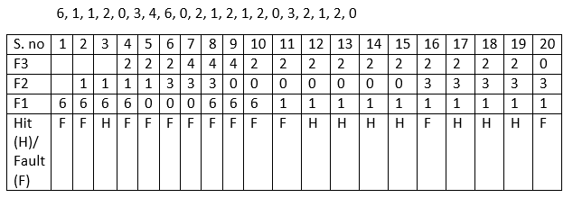
Number of Page Hits = 8
Number of Page Faults = 12
The Ratio of Page Hit to the Page Fault = 8 : 12 - - - > 2 : 3 - - - > 0.66
The Page Hit Percentage = 8 *100 / 20 = 40%
The Page Fault Percentage = 100 - Page Hit Percentage = 100 - 40 = 60%
Explanation
First, fill the frames with the initial pages. Then, after the frames are filled we need to create a space in the frames for the new page to occupy. So, with the help of First in First Out Page Replacement Algorithm we remove the frame which contains the page is older among the pages. By removing the older page we give access for the new frame to occupy the empty space created by the First in First out Page Replacement Algorithm.

OPTIMAL Page Replacement Algorithm
This is the second basic algorithm of Page Replacement Algorithms. This algorithm is basically dependent on the number of frames used. Then each frame takes up the certain page and tries to access it. When the frames are filled then the actual problem starts. The fixed number of frames is filled up with the help of first frames present. This concept is fulfilled with the help of Demand Paging
After filling up of the frames, the next page in the waiting queue tries to enter the frame. If the frame is present then, no problem is occurred. Because of the page which is to be searched is already present in the allocated frames.
If the page to be searched is found among the frames then, this process is known as Page Hit.
If the page to be searched is not found among the frames then, this process is known as Page Fault.
When Page Fault occurs this problem arises, then the OPTIMAL Page Replacement Algorithm comes into picture.
The OPTIMAL Page Replacement Algorithms works on a certain principle. The principle is:
Replace the Page which is not used in the Longest Dimension of time in future
This principle means that after all the frames are filled then, see the future pages which are to occupy the frames. Go on checking for the pages which are already available in the frames. Choose the page which is at last.
Example:
Suppose the Reference String is:
0, 3, 4, 6, 0, 2, 1, 2, 1, 2, 0, 3, 2, 1, 2, 0
6, 1, 2 are in the frames occupying the frames.
Now we need to enter 0 into the frame by removing one page from the page
So, let us check which page number occurs last
From the sub sequence 0, 3, 4, 6, 0, 2, 1 we can say that 1 is the last occurring page number. So we can say that 0 can be placed in the frame body by removing 1 from the frame.
Let us understand this OPTIMAL Page Replacement Algorithm working with the help of an example.
Example:
Consider the reference string 6, 1, 1, 2, 0, 3, 4, 6, 0, 2, 1, 2, 1, 2, 0, 3, 2, 1, 4, 0 for a memory with three frames and calculate number of page faults by using OPTIMAL Page replacement algorithms.
Points to Remember
Page Not Found - - - > Page Fault
Page Found - - - > Page Hit
Reference String:
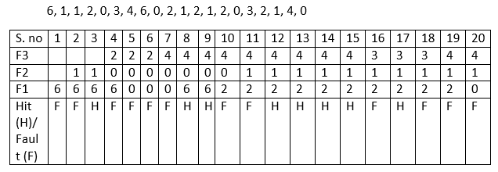
Number of Page Hits = 8
Number of Page Faults = 12
The Ratio of Page Hit to the Page Fault = 8 : 12 - - - > 2 : 3 - - - > 0.66
The Page Hit Percentage = 8 *100 / 20 = 40%
The Page Fault Percentage = 100 - Page Hit Percentage = 100 - 40 = 60%
Explanation
First, fill the frames with the initial pages. Then, after the frames are filled we need to create a space in the frames for the new page to occupy.
Here, we would fill the empty spaces with the pages we and the empty frames we have. The problem occurs when there is no space for occupying of pages. We have already known that we would replace the Page which is not used in the Longest Dimension of time in future.
There comes a question what if there is absence of page which is in the frame.
Suppose the Reference String is:
0, 2, 4, 6, 0, 2, 1, 2, 1, 2, 0, 3, 2, 1, 2, 0
6, 1, 5 are in the frames occupying the frames.
Here, we can see that page number 5 is not present in the Reference String. But the number 5 is present in the Frame. So, as the page number 5 is absent we remove it when required and other page can occupy that position.

Least Recently Used (LRU) Replacement Algorithm
This is the last basic algorithm of Page Replacement Algorithms. This algorithm is basically dependent on the number of frames used. Then each frame takes up the certain page and tries to access it. When the frames are filled then the actual problem starts. The fixed number of frames is filled up with the help of first frames present. This concept is fulfilled with the help of Demand Paging
After filling up of the frames, the next page in the waiting queue tries to enter the frame. If the frame is present then, no problem is occurred. Because of the page which is to be searched is already present in the allocated frames.
If the page to be searched is found among the frames then, this process is known as Page Hit.
If the page to be searched is not found among the frames then, this process is known as Page Fault.
When Page Fault occurs this problem arises, then the Least Recently Used (LRU) Page Replacement Algorithm comes into picture.
The Least Recently Used (LRU) Page Replacement Algorithms works on a certain principle. The principle is:
Replace the page with the page which is less dimension of time recently used page in the past.
Example:
Suppose the Reference String is:
6, 1, 1, 2, 0, 3, 4, 6, 0
The pages with page numbers 6, 1, 2 are in the frames occupying the frames.
Now, we need to allot a space for the page numbered 0.
Now, we need to travel back into the past to check which page can be replaced.
6 is the oldest page which is available in the Frame.
So, replace 6 with the page numbered 0.
Let us understand this Least Recently Used (LRU) Page Replacement Algorithm working with the help of an example.
Example:
Consider the reference string 6, 1, 1, 2, 0, 3, 4, 6, 0, 2, 1, 2, 1, 2, 0, 3, 2, 1, 2, 0 for a memory with three frames and calculate number of page faults by using Least Recently Used (LRU) Page replacement algorithms.
Points to Remember
Page Not Found - - - > Page Fault
Page Found - - - > Page Hit
Reference String:
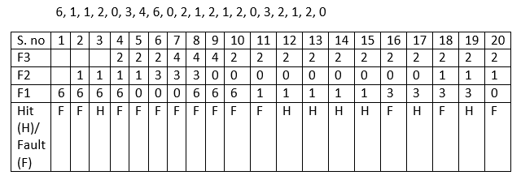
Number of Page Hits = 7
Number of Page Faults = 13
The Ratio of Page Hit to the Page Fault = 7 : 12 - - - > 0.5833 : 1
The Page Hit Percentage = 7 * 100 / 20 = 35%
The Page Fault Percentage = 100 - Page Hit Percentage = 100 - 35 = 65%
Explanation
First, fill the frames with the initial pages. Then, after the frames are filled we need to create a space in the frames for the new page to occupy.
Here, we would fill the empty spaces with the pages we and the empty frames we have. The problem occurs when there is no space for occupying of pages. We have already known that we would replace the Page which is not used in the Longest Dimension of time in past or can be said as the Page which is very far away in the past.

Belady'sAnomaly
In the case of LRU and optimal page replacement algorithms, it is seen that the number of page faults will be reduced if we increase the number of frames. However, Balady found that, In FIFO page replacement algorithm, the number of page faults will get increased with the increment in number of frames.
This is the strange behavior shown by FIFO algorithm in some of the cases. This is an Anomaly called as Belady'sAnomaly.
Let's examine such example :
The reference String is given as 0 1 5 3 0 1 4 0 1 5 3 4. Let's analyze the behavior of FIFO algorithm in two cases.

Case 1: Number of frames = 3
Request | 0 | 1 | 5 | 3 | 0 | 1 | 4 | 0 | 1 | 5 | 3 | 4
Frame 3 |  |  | 5 | 5 | 5 | 1 | 1 | 1 | 1 | 1 | 3 | 3
Frame 2 |  | 1 | 1 | 1 | 0 | 0 | 0 | 0 | 0 | 5 | 5 | 5
Frame 1 | 0 | 0 | 0 | 3 | 3 | 3 | 4 | 4 | 4 | 4 | 4 | 4
Miss/Hit | Miss | Miss | Miss | Miss | Miss | Miss | Miss | Hit | Hit | Miss | Miss | Hit
Number of Page Faults = 9

Case 2: Number of frames = 4
Request | 0 | 1 | 5 | 3 | 0 | 1 | 4 | 0 | 1 | 5 | 3 | 4
Frame 4 |  |  |  | 3 | 3 | 3 | 3 | 3 | 3 | 5 | 5 | 5
Frame 3 |  |  | 5 | 5 | 5 | 5 | 5 | 5 | 1 | 1 | 1 | 1
Frame 2 |  | 1 | 1 | 1 | 1 | 1 | 1 | 0 | 0 | 0 | 0 | 4
Frame 1 | 0 | 0 | 0 | 0 | 0 | 0 | 4 | 4 | 4 | 4 | 3 | 3
Miss/Hit | Miss | Miss | Miss | Miss | Hit | Hit | Miss | Miss | Miss | Miss | Miss | Miss
Number of Page Faults = 10
Therefore, in this example, the number of page faults is increasing by increasing the number of frames hence this suffers from Belady'sAnomaly.

Segmentation in OS (Operating System)
In Operating Systems, Segmentation is a memory management technique in which the memory is divided into the variable size parts. Each part is known as a segment which can be allocated to a process.
The details about each segment are stored in a table called a segment table. Segment table is stored in one (or many) of the segments.
Segment table contains mainly two information about segment:
- Base: It is the base address of the segment
- Limit: It is the length of the segment.

Why Segmentation is required?
Till now, we were using Paging as our main memory management technique. Paging is more close to the Operating system rather than the User. It divides all the processes into the form of pages regardless of the fact that a process can have some relative parts of functions which need to be loaded in the same page.
Operating system doesn't care about the User's view of the process. It may divide the same function into different pages and those pages may or may not be loaded at the same time into the memory. It decreases the efficiency of the system.
It is better to have segmentation which divides the process into the segments. Each segment contains the same type of functions such as the main function can be included in one segment and the library functions can be included in the other segment.
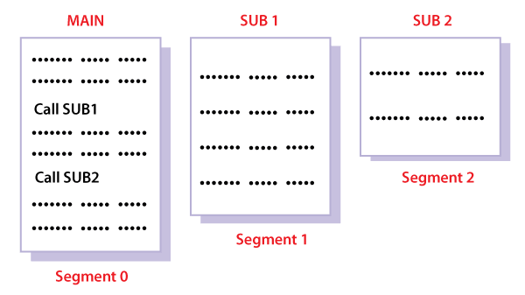

Translation of Logical address into physical address by segment table
CPU generates a logical address which contains two parts:
- Segment Number
- Offset
For Example:
Suppose a 16 bit address is used with 4 bits for the segment number and 12 bits for the segment offset so the maximum segment size is 4096 and the maximum number of segments that can be refereed is 16.
When a program is loaded into memory, the segmentation system tries to locate space that is large enough to hold the first segment of the process, space information is obtained from the free list maintained by memory manager. Then it tries to locate space for other segments. Once adequate space is located for all the segments, it loads them into their respective areas.
The operating system also generates a segment map table for each program.
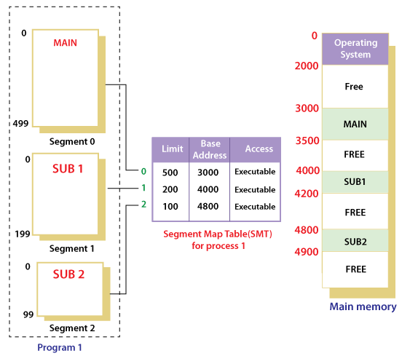
With the help of segment map tables and hardware assistance, the operating system can easily translate a logical address into physical address on execution of a program.
The Segment number is mapped to the segment table. The limit of the respective segment is compared with the offset. If the offset is less than the limit then the address is valid otherwise it throws an error as the address is invalid.
In the case of valid addresses, the base address of the segment is added to the offset to get the physical address of the actual word in the main memory.
The above figure shows how address translation is done in case of segmentation.

Advantages of Segmentation
- No internal fragmentation
- Average Segment Size is larger than the actual page size.
- Less overhead
- It is easier to relocate segments than entire address space.
- The segment table is of lesser size as compared to the page table in paging.

Disadvantages
- It can have external fragmentation.
- it is difficult to allocate contiguous memory to variable sized partition.
- Costly memory management algorithms.

Difference between Paging and Segmentation
Sr No. | Paging | Segmentation
1 | Non-Contiguous memory allocation | Non-contiguous memory allocation
2 | Paging divides program into fixed size pages. | Segmentation divides program into variable size segments.
3 | OS is responsible | Compiler is responsible.
4 | Paging is faster than segmentation | Segmentation is slower than paging
5 | Paging is closer to Operating System | Segmentation is closer to User
6 | It suffers from internal fragmentation | It suffers from external fragmentation
7 | There is no external fragmentation | There is no external fragmentation
8 | Logical address is divided into page number and page offset | Logical address is divided into segment number and segment offset
9 | Page table is used to maintain the page information. | Segment Table maintains the segment information
10 | Page table entry has the frame number and some flag bits to represent details about pages. | Segment table entry has the base address of the segment and some protection bits for the segments.

Segmented Paging
Pure segmentation is not very popular and not being used in many of the operating systems. However, Segmentation can be combined with Paging to get the best features out of both the techniques.
In Segmented Paging, the main memory is divided into variable size segments which are further divided into fixed size pages.
- Pages are smaller than segments.
- Each Segment has a page table which means every program has multiple page tables.
- The logical address is represented as Segment Number (base address), Page number and page offset.

Context Switching in OS (Operating System)
The Context switching is a technique or method used by the operating system to switch a process from one state to another to execute its function using CPUs in the system. When switching perform in the system, it stores the old running process's status in the form of registers and assigns the CPU to a new process to execute its tasks. While a new process is running in the system, the previous process must wait in a ready queue. The execution of the old process starts at that point where another process stopped it. It defines the characteristics of a multitasking operating system in which multiple processes shared the same CPU to perform multiple tasks without the need for additional processors in the system.

The need for Context switching
A context switching helps to share a single CPU across all processes to complete its execution and store the system's tasks status. When the process reloads in the system, the execution of the process starts at the same point where there is conflicting.
Following are the reasons that describe the need for context switching in the Operating system.
- The switching of one process to another process is not directly in the system. A context switching helps the operating system that switches between the multiple processes to use the CPU's resource to accomplish its tasks and store its context. We can resume the service of the process at the same point later. If we do not store the currently running process's data or context, the stored data may be lost while switching between processes.
- If a high priority process falls into the ready queue, the currently running process will be shut down or stopped by a high priority process to complete its tasks in the system.
- If any running process requires I/O resources in the system, the current process will be switched by another process to use the CPUs. And when the I/O requirement is met, the old process goes into a ready state to wait for its execution in the CPU. Context switching stores the state of the process to resume its tasks in an operating system. Otherwise, the process needs to restart its execution from the initials level.
- If any interrupts occur while running a process in the operating system, the process status is saved as registers using context switching. After resolving the interrupts, the process switches from a wait state to a ready state to resume its execution at the same point later, where the operating system interrupted occurs.
- A context switching allows a single CPU to handle multiple process requests simultaneously without the need for any additional processors.

Example of Context Switching
Suppose that multiple processes are stored in a Process Control Block (PCB). One process is running state to execute its task with the use of CPUs. As the process is running, another process arrives in the ready queue, which has a high priority of completing its task using CPU. Here we used context switching that switches the current process with the new process requiring the CPU to finish its tasks. While switching the process, a context switch saves the status of the old process in registers. When the process reloads into the CPU, it starts the execution of the process when the new process stops the old process. If we do not save the state of the process, we have to start its execution at the initial level. In this way, context switching helps the operating system to switch between the processes, store or reload the process when it requires executing its tasks.

Context switching triggers
Following are the three types of context switching triggers as follows.
- Interrupts
- Multitasking
- Kernel/User switch
Interrupts: A CPU requests for the data to read from a disk, and if there are any interrupts, the context switching automatic switches a part of the hardware that requires less time to handle the interrupts.
Multitasking: A context switching is the characteristic of multitasking that allows the process to be switched from the CPU so that another process can be run. When switching the process, the old state is saved to resume the process's execution at the same point in the system.
Kernel/User Switch: It is used in the operating systems when switching between the user mode, and the kernel/user mode is performed.

What is the PCB?
A PCB (Process Control Block) is a data structure used in the operating system to store all data related information to the process. For example, when a process is created in the operating system, updated information of the process, switching information of the process, terminated process in the PCB.

Steps for Context Switching
There are several steps involves in context switching of the processes. The following diagram represents the context switching of two processes, P1 to P2, when an interrupt, I/O needs, or priority-based process occurs in the ready queue of PCB.
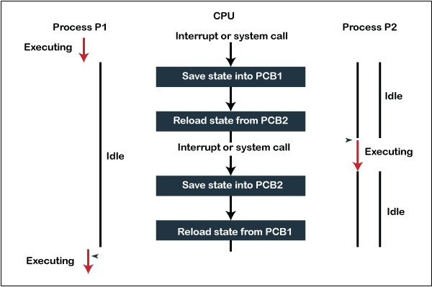
As we can see in the diagram, initially, the P1 process is running on the CPU to execute its task, and at the same time, another process, P2, is in the ready state. If an error or interruption has occurred or the process requires input/output, the P1 process switches its state from running to the waiting state. Before changing the state of the process P1, context switching saves the context of the process P1 in the form of registers and the program counter to the PCB1. After that, it loads the state of the P2 process from the ready state of the PCB2 to the running state.
The following steps are taken when switching Process P1 to Process 2:
- First, thes context switching needs to save the state of process P1 in the form of the program counter and the registers to the PCB (Program Counter Block), which is in the running state.
- Now update PCB1 to process P1 and moves the process to the appropriate queue, such as the ready queue, I/O queue and waiting queue.
- After that, another process gets into the running state, or we can select a new process from the ready state, which is to be executed, or the process has a high priority to execute its task.
- Now, we have to update the PCB (Process Control Block) for the selected process P2. It includes switching the process state from ready to running state or from another state like blocked, exit, or suspend.
- If the CPU already executes process P2, we need to get the status of process P2 to resume its execution at the same time point where the system interrupt occurs.
Similarly, process P2 is switched off from the CPU so that the process P1 can resume execution. P1 process is reloaded from PCB1 to the running state to resume its task at the same point. Otherwise, the information is lost, and when the process is executed again, it starts execution at the initial level.

Internal vs. External Fragmentation

What is Fragmentation?
"Fragmentation is a process of data storage in which memory space is used inadequately, decreasing ability or efficiency and sometimes both." The precise implications of fragmentation depend on the specific storage space allocation scheme in operation and the particular fragmentation type. In certain instances, fragmentation contributes to "unused" storage capacity, and the concept also applies to the unusable space generated in that situation. The memory used to preserve the data set (- for example file format) is similar for other systems (- for example, the FAT file system), regardless of the amount of fragmentation (from null to the extreme).
There are three distinct fragmentation kinds: internal fragmentation, external fragmentation, and data fragmentation that can exist beside or a combination. In preference for enhancements, inefficiency, or usability, fragmentation is often acknowledged. For other tools, such as processors, similar things happen.

The Fundamental concept of Fragmentation
When a computer program demands fragments of storage from the operating system (OS), the elements are assigned in chunks. When a chunk of the software program is completed, it can be released back to the system, making it ready to be transferred to the next or the similar program again afterward. Software differs in the size and duration of time a chunk is kept by it. A computer program can demand and release several blocks of storage throughout its lifetime.
The unused memory sections are large and continuous when a system is initiated. The large continuous sectors become fragmented into a smaller part of the regions through time and utilization. Ultimately, accessing large contiguous blocks of storage can become difficult for the system.
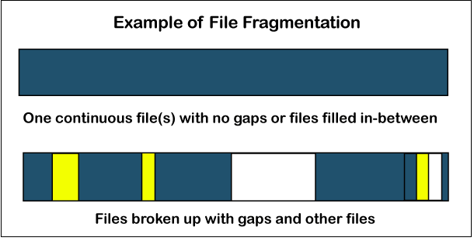

Internal Fragmentation
Most memory space is often reserved than is required to adhere to the restrictions regulating storage space. For instance, memory can only be supplied in blocks (multiple of 4) to systems, and as an outcome, if a program demands maybe 29 bytes, it will get a coalition of 32 bytes. The surplus storage goes to waste when this occurs. The useless space is found inside an assigned area in this case. This structure, called fixed segments, struggles from excessive memory-any process consumes an enormous chunk, no matter how insignificant. Internal fragmentation is what this garbage is termed. Unlike many other forms of fragmentation, it is impossible to restore inner fragmentation, typically, the only way to eliminate it is with a new design.
For instance, in dynamic storage allocation, storage reservoirs reduce internal fragmentation significantly by extending the space overhead over a more significant number of elements.
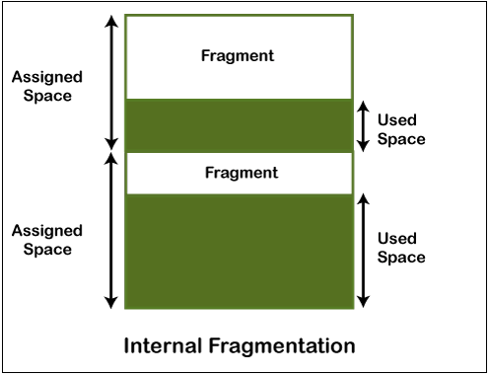
The figure mentioned above demonstrates internal fragmentation because internal fragmentation is considered the distinction between the assigned storage space and the needed space or memory.

External Fragmentation
When used storage is differentiated into smaller lots and is punctuated by assigned memory space, external fragmentation occurs. It is a weak point of many storage allocation methodologies when they cannot effectively schedule memory used by systems. The consequence is that, while unused storage is available, it is essentially inaccessible since it is separately split into fragments that are too limited to meet the software's requirements. The word "external" derives from the fact that the inaccessible space is stored outside the assigned regions.
Consider, for instance, a scenario in which a system assigns three consecutive memory blocks and then relieves the middle block. The memory allocator can use this unused allocation of the storage for future assignments. Fortunately, if the storage to be reserved is more generous in size than this available region, it will not use this component.
In data files, external fragmentation often exists when several files of various sizes are formed, resized, and discarded. If a broken document into several small chunks is removed, the impact is much worse since this retains equally small free space sections.
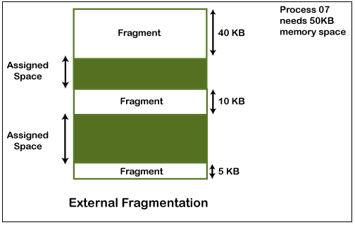
You can see in the figure mentioned above that there is sufficient memory space (55 KB) to execute a process-07 (50 KB mandated), but the storage (fragment) is not adjacent. Here, to use the empty room to run a procedure, you can use compression, paging, or segmentation strategies.

Internal fragmentation vs. External fragmentation

Here, the differences between Internal and External Fragmentation are discussed below in the tabular format.
Sr. No. | Internal Fragmentation | External Fragmentation
1. | Frames square measure designated for processing in internal fragmentation of fixed-sized storage. | Variable-sized memory frames square measure designated to the process during external fragmentation.
2. | When the system or procedure is greater than the storage, internal fragmentation occurs. | Whenever the system or procedure is withdrawn, external fragmentation occurs.
3. | The internal fragmentation approach is the frame with the perfect match. | Compression, paging, and differentiation are alternatives to external fragmentation.
4. | Internal fragmentation happens whenever the storage is split into fragments of a fixed length. | External fragmentation happens whenever the storage is split into segments of variable size depending on the process length.
5. | The distinction between the assigned memory and the storage or memory needed is considered as internal fragmentation. | The empty spaces created among non-contiguous pieces of storage are too tiny for a new system to operate, considered as external fragmentation.

Multiprocessing Operating system (UNIX)
In operating systems, to improve the performance of more than one CPU can be used within one computer system called Multiprocessor operating system.
Multiple CPUs are interconnected so that a job can be divided among them for faster execution. When a job finishes, results from all CPUs are collected and compiled to give the final output. Jobs needed to share main memory and they may also share other system resources among themselves. Multiple CPUs can also be used to run multiple jobs simultaneously.
For Example: UNIX Operating system is one of the most widely used multiprocessing systems.
The basic organization of a typical multiprocessing system is shown in the given figure.
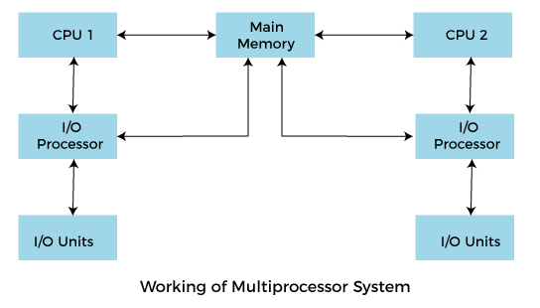
To employ a multiprocessing operating system effectively, the computer system must have the following things:
- A motherboard is capable of handling multiple processors in a multiprocessing operating system.
- Processors are also capable of being used in a multiprocessing system.

Advantages of multiprocessing operating system are:
- Increased reliability: Due to the multiprocessing system, processing tasks can be distributed among several processors. This increases reliability as if one processor fails; the task can be given to another processor for completion.
- Increased throughout: As several processors increase, more work can be done in less
- The economy of Scale: As multiprocessors systems share peripherals, secondary storage devices, and power supplies, they are relatively cheaper than single-processor systems.

Disadvantages of Multiprocessing operating System
- Operating system of multiprocessing is more complex and sophisticated as it takes care of multiple CPUs at the same time.

Types of multiprocessing systems
- Symmetrical multiprocessing operating system
- Asymmetric multiprocessing operating system

Symmetrical multiprocessing operating system:
In a Symmetrical multiprocessing system, each processor executes the same copy of the operating system, takes its own decisions, and cooperates with other processes to smooth the entire functioning of the system. The CPU scheduling policies are very simple. Any new job submitted by a user can be assigned to any processor that is least burdened. It also results in a system in which all processors are equally burdened at any time.
The symmetric multiprocessing operating system is also known as a "shared every-thing" system, because the processors share memory and the Input output bus or data path. In this system processors do not usually exceed more than 16.
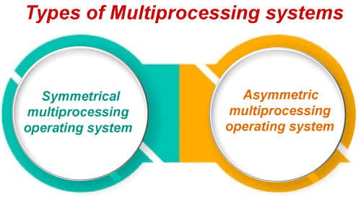
Characteristics of Symmetrical multiprocessing operating system:
- In this system, any processor can run any job or process.
- In this, any processor initiates an Input and Output operation.
Advantages of Symmetrical multiprocessing operating system:
- These systems are fault-tolerant. Failure of a few processors does not bring the entire system to a halt.
Disadvantages of Symmetrical multiprocessing operating system:
- It is very difficult to balance the workload among processors rationally.
- Specialized synchronization schemes are necessary for managing multiple processors.

Asymmetric multiprocessing operating system
In an asymmetric multiprocessing system, there is a master slave relationship between the processors.
Further, one processor may act as a master processor or supervisor processor while others are treated as shown below.
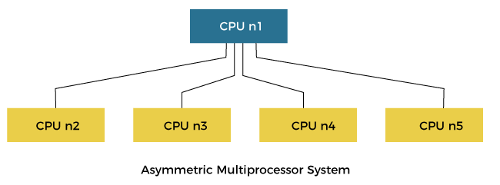
In the above figure, the asymmetric processing system shows that CPU n1 acts as a supervisor whose function controls other following processors.
In this type of system, each processor is assigned a specific task, and there is a designated master processor that controls the activities of other processors.
For example, we have a math co-processor that can handle mathematical jobs better than the main CPU. Similarly, we have an MMX processor that is built to handle multimedia-related jobs. Similarly, we have a graphics processor to handle the graphics-related job better than the main processor. When a user submits a new job, the OS has to decide which processor can perform it better, and then that processor is assigned that newly arrived job. This processor acts as the master and controls the system. All other processors look for masters for instructions or have predefined tasks. It is the responsibility of the master to allocate work to other processors.
Advantages of Asymmetric multiprocessing operating system:
- In this type of system execution of Input and Output operation or an application program may be faster in some situations because many processors may be available for a single job.
Disadvantages of Asymmetric multiprocessing operating system:
- In this type of multiprocessing operating system the processors are unequally burdened. One processor may be having a long job queue, while another one may be sitting idle.
- In this system, if the process handling a specific work fails, the entire system will go down.

